 | Departments | Undergraduate Program | Graduate Programs

Faculty of sciences
Total Departments | 10 | Total Programs | 20
List of Departments
Name | Undergraduate Programs | Graduate Programs | Doctor Program

Enrolled Students 897
Gender Position in Department
Degree Wise Students
Location wise Applications
Yearly admitted
Yearly Pass out or degree wise Pass out
Scholarship Avail Department wise
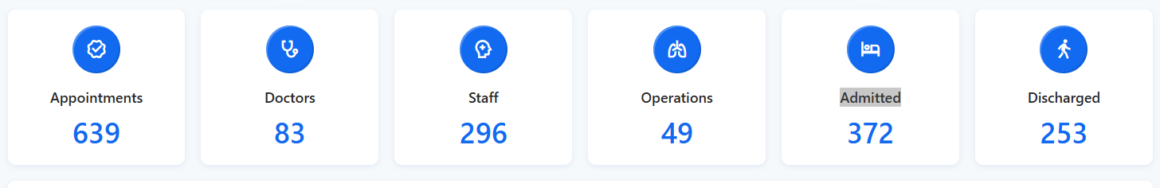

Graduated , Current Enrolled
https://apexcharts.com/javascript-chart-demos/bar-charts/reversed-bar-chart/ yearly Enrolled / Realr pass out
https://apexcharts.com/javascript-chart-demos/dashboards/material/

https://apexcharts.com/javascript-chart-demos/pie-charts/update-donut/
https://apexcharts.com/javascript-chart-demos/funnel-charts/funnel/

https://apexcharts.com/javascript-chart-demos/bar-charts/basic/

https://apexcharts.com/javascript-chart-demos/bar-charts/stacked/ yearly admitted BS/MS/BS Fifth ?Mphil/ Phd or Yealy enrollment BS/MS/BS fifth/Mphil
https://apexcharts.com/javascript-chart-demos/bar-charts/stacked-100/

SELECT city_name AS City, COUNT( * ) AS Total

FROM adm_application AS a INNER JOIN adm_candidate AS cand ON a.cand_id = cand.cand_id
INNER JOIN u_city AS c ON c.city_id = cand.cand_domicile
inner join adm_application as app on app.cand_id = cand.cand_id
inner join adm_appdo as ado on ado.app_id = app.app_id
inner join u_degreeoffered as do on do.do_id = ado.do_id
WHERE do.dept_id = 19
and app.app_status in ('v','r','j')
GROUP BY city_name
order by Total desc; city wise applicants

