UNIVERSITY OF GUJRAT
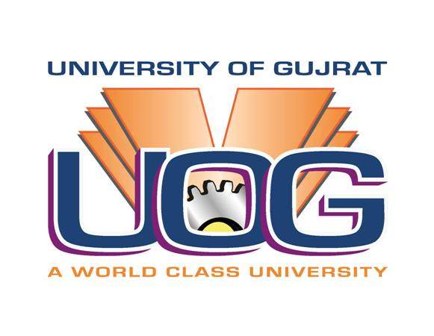
Terms of Reference (TORS) of Consultancy Service
For the Work Titled:
1. Soil Investigation, Foundation & Structural Design of Building, Construction & Architectural Drawings for the Work “Enhancement of Capacity of Jamia Masjid UOG and Augmentation / Revamping of Facilities”.
2. Master Planning of New Acquired Land 127 Kanal 01 Marla, Soil Investigation and Complete Architectural & Structural Design and Drawings of the Foundation and Superstructure for the Work “Construction of Main Entrance / Gate, Boundary Wall and Security Check Post/s at Hafiz Hayat Campus”.
1. Introduction:
The Schemes titled “Enhancement of Capacity of Jamia Masjid UOG and Augmentation / Revamping of Facilities” and “Construction of Main Entrance / Gate, Boundary Wall and Security Check Post/s at Hafiz Hayat Campus” have been approved by the competent forum. The estimated cost of the consultancy is Rs. 1.20 Million and Rs. 1.75 Million respectively, will be financed by the UOG. In this regard, the Competent Authority, UOG has decided to hire the services of a consultant before undertaking Work of the said schemes.
2. Scope and Services:
The Consultant should be required to undertake both works, carry out / supervise all lab / field test and will be responsible for all related matters pertaining to the recommendations of the execution of the said schemes.
2.1. Qualification of Consultant:
The Consultant should be a registered firm with Pakistan Engineering Council (PEC) and having minimum 10 Years’ experience of designing and Civil Works. The Consulting Firm is eligible for participation for Financial Proposals, who have already pre-qualified in the said field and at approved panel of Planning and Development (P&D), Government of the Punjab. In this regard TORs will be as under:
Sr# | Description
1 | Name of the Client: University of Gujrat  Method of Selection: Quality and Cost Based Selection Method
2 | Financial Proposal to be submitted together with Technical Proposal for the Assignment:  1. Soil Investigation, 3 bore borehole as per site condition, Foundation & Structural Design of Building, Construction & Architectural Drawings for the Work “Enhancement of Capacity of Jamia Masjid UOG and Augmentation / Revamping of Facilities”.  2. Master Planning of New Acquired Land 127 Kanal 01 Marla, Soil Investigation, 3 bore borehole as per site condition and Complete Architectural & Structural Design and Drawings of the Foundation and Superstructure for the Work “Construction of Main Entrance / Gate, Boundary Wall and Security Check Post/s at Hafiz Hayat Campus”.
3 | The client will provide facilitation possible to the Consultant which will be mutually decided at the time of agreement.
4 | Proposals must remain valid till 60 days after the submission date as per rules.
5 | Proposal shall be submitted in English Language
6 | 1. Firms should submit details of 5 completed major relevant assignments along with Technical Proposal.  2. Firm must have to submit its complete profile accompanying, ID Card, Registration with FBR & Punjab Revenue Authority for PST and PEC along with pre-qualification letter issued by the P&D.
7 | Amounts payable by the client to the consultants under the agreement will be subject to all local / Govt. taxation.
8 | Consultant must submit the copies of the Technical Proposal (hard copy), and original Financial Bid.
9 | The Proposal submission address is:  The Directorate of Works, VC Secretariat, Hafiz Hayat Campus, University of Gujrat, Gujrat  Proposal must be submitted within the following Date and Time as advertised:  Date: 19th March, 2024 at Time:12:30 PM.

__________________
Signature & Stamp

QUOTATIONS FOR FINANCIAL PROPOSAL
Sr. No. | Name of Work | Estimated Cost  (Rs. in Million) | Completion Time | Quotation Rate
1 | Soil Investigation, Foundation & Structural Design of Building, Construction & Architectural Drawings for the Work “Enhancement of Capacity of Jamia Masjid UOG and Augmentation / Revamping of Facilities”. | 1.20 | 45 Days
2 | Master Planning of New Acquired Land 127 Kanal 01 Marla, Soil Investigation and Complete Architectural & Structural Design and Drawings of the Foundation and Superstructure for the Work “Construction of Main Entrance / Gate, Boundary Wall and Security Check Post/s at Hafiz Hayat Campus”. | 1.75
 | Total Amount | Rs. 2.95

__________________
Signature & Stamp

